The Mission of Testing Services at SIU is to provide a professional testing environment for the campus and community. This enables test takers to perform at their maximum ability and provide services to assist students and faculty in maintaining the University’s goal of academic excellence. In order to provide professional standards the reflect positively on the University, Testing Services maintains membership with and adheres to guidelines set forth by the National College Testing Association (NCTA).
The RegisterBlast Professor Portal allows SIU Instructors to submit their exams directly to the student Registration portal, which is designed to simplify the process of submitting materials to SIU Testing Services.

How to Enroll for RegisterBlast:
- Use the following link to enroll as professor on the RegisterBlast website.
  - https://www2.registerblast.com/carbondale/Professor/enroll
  - Complete the Enrollment form
    - Password
    - First Name
    - Last Name
    - Email (siu is preferred, but use the email you will check)
    - Phone number
    - Department
    - Type of exams you are submitting (make-up, Extended Campus, Nursing, etc.)
    - Choose “Never” for Student List Notification Type
    - Choose “No” for both Notify when a submission changes and Notify when testing is complete.
- The Instructor will receive a confirmation of enrollment and email.
- The Testing Services Coordinator will look at your submission and approve it before you will be able to submit any exams.

Exam Professor Submission:
- Click on https://www2.registerblast.com/carbondale/Professor/login to access Submission Page to submit exams after the initial enrollment. Bookmark this link for easy access in the future.
- Click the link in #1 and log into the RegisterBlast Professor Submission portal using the same password and email used to create the account. Once logged in,
- Once you are logged in The Submission Tab will be at the upper right corner of the page, if you are not already on the Submissions page.
- Click on the + sign in the upper right corner of the page. The Submission Builder will open up.
  - Complete the Submission Form
    - Exam Name: Please use the following formula, Class Acronym, Section, and name of exam. (Math 101, 950, exam 1)
    - Select exam group (this is so Testing Services and group your exams correctly for student to sign up for)
    - Exam start date and end date (the days that the exams are open for, no less than 2 days)
    - Ignore the Time Restriction link
    - Input the allotted minutes students are allowed to take the exam.
    - Submit any paper exams or files needed/allowed with the exam. (For instance, a formula sheet or periodic table). You can include as many files as needed. For Extended Campus exams, if you DO NOT have the exam ready, you can still submit the form and add the exam later. Please add your exams at least a week before the beginning of the exam date. If you are submitting a make-up exam, all materials need to be submitted at the same time. We ask that you give us 2 full work days to process your request.
    - Department Name:
    - Course Title: (ie. Introduction to Contemporary Mathematics):
    - Course Acronym and Section Number (Math 101-950):
    - Online or paper exam:
    - Materials allowed:
    - If it’s a make-up exam, the name of the student taking the exam:
    - How you want your exams returned:
    - Any additional Exam instructions:
  - The Testing Services Coordinator will review your submission and approve it or will contact you directly for any follow up questions.

Frequently Asked Questions:
How do I extend the deadline for a previously submitted exam? Send an email testing@siu.edu with the exam name and the new deadline dates and we will update your exam accordingly.
I chose the wrong allotted minutes for the exam. How do I fix it? Send an email to testing@siu.edu with the exam name and the new exam duration. Note: Since scheduling issues may occur if the exam duration changes after appointments have been made, faculty cannot edit the allotted minutes after submissions. The may require Testing Center staff to change the information under “Exam” and/or run a report of students who have registered for your exam prior to the change and to make manual adjustments.
How do I know you received the exam and that everything worked properly? RegisterBlast immediately processes exam submissions to the Admin Portal for approval. From your Professor Portal, click on submissions at the top of the page, this contains a list of all your submitted exams. This is what the submission page will look like.
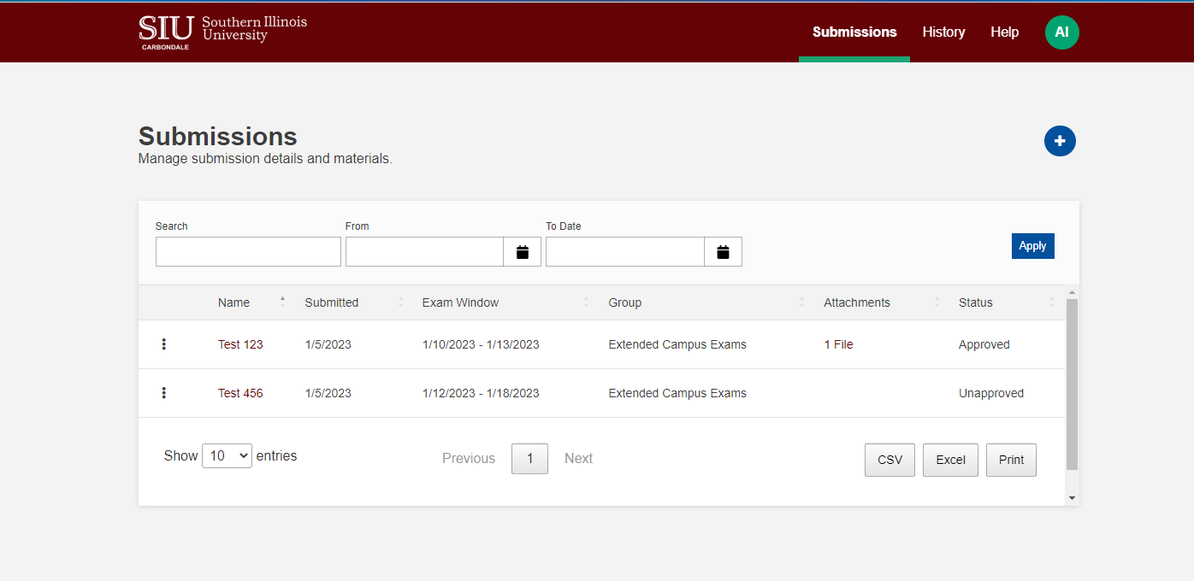

Why can’t I just email Testing Services my exam? Due to the large number of emails we receive, we want to ensure students receive timely and accurate service. By submitting the exam via RegisterBlast, we ensure that students can schedule sooner and faster. Moreover, any changes you make to the submission, including proctoring instructions, eligible students or even the exam document itself take immediate effect.
Do I have to make a new submission for each exam? Yes, you will need to make a new submission for each exam since many times there may be differences from one exam to the next. There is a shortcut to making multiple submissions. If you look at a previous submission, there will be 3 dots on the left. Click the dots and “clone” the exam. You can then change the dates, submit different documents, etc. This will make it a littler easier to submit multiple tests for the semester.
Note: If you are already aware of your exam dates, please try to submit your exams at the beginning of the semester. This way, we can add your dates to the calendar and anticipate when we may need more staff available and better serve faculty and student’s needs.
*There is also Professor help through RegisterBlast, near the upper right-hand corner, click on the “Help” tab.

